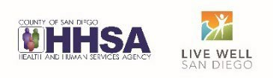
County of San Diego – Health and Human Services Agency (HHSA)
Behavioral Health Services (BHS) – Information Notice
To:  From: | Mental Health Contracted Day Treatment Service Providers  Behavioral Health Services – Quality Management Unit
Date: | November 29, 2022
Title | Day Treatment CalAIM and Contract requirement updates

The Department of Health Care Services (DHCS) final information notice regarding documentation reform, BHIN 22-019 ca.gov) went into effect July 1, 2022. New requirements aiming to improve the beneficiary experience by streamlining and standardizing clinical documentation requirements across Medi-Cal SMHS, DMC, and DMC-ODS services included changes to the current Day Treatment requirements. Therefore, as of 01/01/23 the following standards will be set:

- Day Treatment providers are required to complete a daily progress note for services that are billed daily, this includes therapeutic foster care, day treatment intensive, and day rehabilitation. A paper version has been utilized but shall transition to EHR format
- Weekly Summaries are no longer required

In addition, the latest DHCS boilerplate contract with counties identifies the following changes:

- The documentation of Avoidable and Unavoidable absences has been removed
- Beneficiaries must attend a minimum of 50% of treatment hours to be billed
- Programs may include meals and breaks in their submitted schedules if the treatment hours are not reduced

Daily Progress Note:

In keeping with the regulations for day treatment, a new Daily Progress Note has been created in CCBH (no changes to the TFC daily note available in CCHB). This note must be completed in the EHR for all days the services are provided. Programs with five days of services per week would enter five Daily Progress Notes. Programs offering six days of services enter six Daily Progress Notes in the EHR. The progress note must be entered into CCBH within three business days.

Programs need to be prepared to have appropriate staff entering the Daily Progress Notes into CCBH. The notes are non-billable and may be completed by any level of staff, however the staff must have access to CCBH. Staff who currently need to enter daily progress notes and do not yet have CCBH access must have ARFs submitted and be signed up for the appropriate CCBH training. There will be no change in the way in which services are claimed.

All DHCS requirements are included in the Daily Progress Note template and are to be addressed, if applicable. For any area not applicable on that day, staff may enter “N/A” is an appropriate response.
The Daily Note may be selected from the New Progress Note button, under Never-Billable Progress Note (see screen shot below):
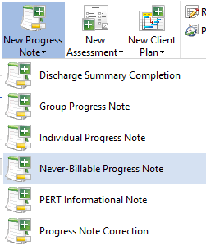

Once this note has been opened, enter the date for the service and click save:

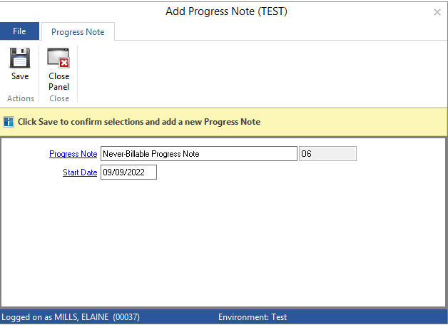

Above the Client Narrative section, click on the drop-down menu of templates and select the Daily Note template: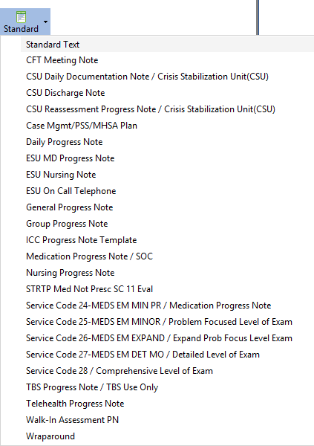
Select Daily Progress Note Template from the drop-down under the “Standard” icon in the Progress Note Narrative.

The Daily Progress Note Prompts include all the required information included in the DHCS CalAIM regulations:

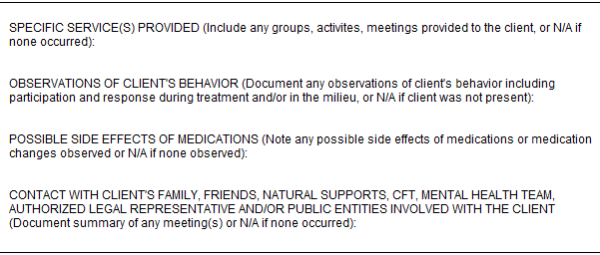

For More Information:
HHSA, QI Matters: qimatters.hhsa@sdcounty.ca.gov
1 of 1 11/29/2022

